Here's the list of Flutter widgets from 1 to 200 with symbols added for examples:
- About Dialog - ⓘ
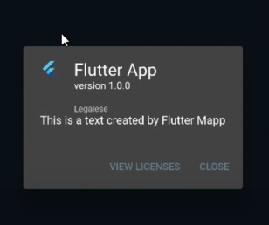

- About List Tile - 📋
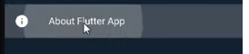
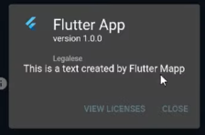
- Absorb Pointer - 🚫
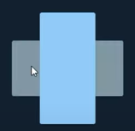
- Alert Dialog - ⚠️
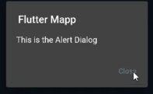
- Align - ↕️

- Animated Align - ↖️

- 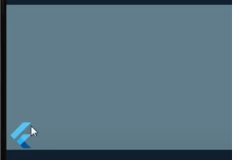
- Animated Builder - 🛠️
- Animated Container - 📦
- Animated Cross Fade - ↔️
- Animated Default Text Style - 🅰️
- Animated Icon - ➡️
- Animated List - 📜
- Animated Modal Barrier - 🚧
- Animated Opacity - 🌫️
- Animated Padding - 📏
- Animated Physical Model - 🏠
- Animated Positioned - 📍
- Animated Rotation - 🔄
- Animated Size - ↔️🔛
- Animated Switcher - 🔄🆗
- App Bar - 🍸

- Aspect Ratio - 🔄🔲
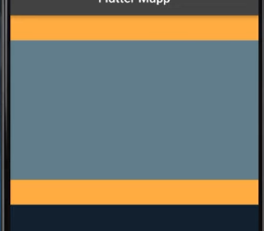
- Auto Complete - ✅📝
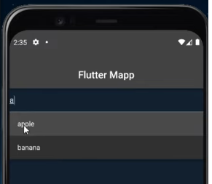
- Backdrop Filter - 🎬
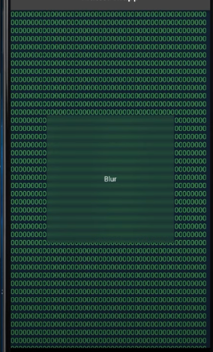
- Banner - 🚩

- Baseline - 📏

- Block Semantics - 🔲
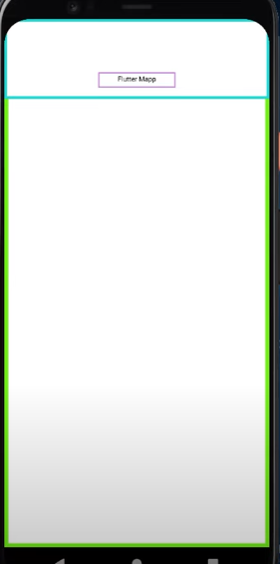
- Bottom Navigation Bar - 🧭
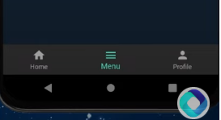
- Bottom Sheet - 📄
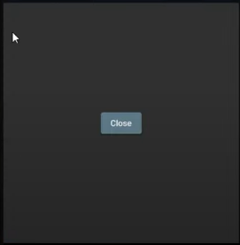

- Builder - 👷
- Card - 🃏
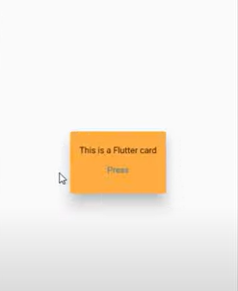
- Center - ⭕
- Checkbox - ☑️

- Checkbox List Tile - ☑️📋
- Chip - 🍪
- Choice Chip - 🆚
- Circle Avatar - ⭕👤

- Circular Progress Indicator - ⏳
- Clip Oval - 🥚
- Clip Path - ✂️📐

- ClipRect - ▭
- ClipRRect - ▭🌑

- Close Button - ❌
- Colored Box - 🟦

- Color Filtered - 🌈
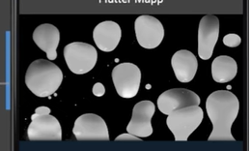
- Constrained Box - 🔳
- Container - 📦
- Column - 🏛️
- Cupertino Action Sheet Action - 📲🔽
- Cupertino App - 🍎📱
- Cupertino Activity Indicator - 🔄
- Cupertino Alert Dialog - 🍎⚠️
- Cupertino Button - 🍎🔘
- Cupertino Context Menu - 🍎📋
- Cupertino Date Picker - 🍎📅
- Cupertino Page Route - 🍎🛣️
- Cupertino Page Scaffold - 🍎🏗️
- Cupertino Picker - 🍎🎚️
- Cupertino Popup Surface - 🍎🔲
- Cupertino Scroll Bar - 🍎📜
- Cupertino Search Text Field - 🔍
- Cupertino Segmented Control - 🍎🔀
- Cupertino Slider - 🍎🎚️
- Cupertino Sliding Segmented Control - 🍎🔀🎚️
- Cupertino Switch - 🍎🔄
- Cupertino Tab Scaffold - 🍎📑
- Cupertino Tab Bar - 🍎📑👇
- Cupertino Tab View - 🍎👀
- Cupertino Text Field - 🍎✍
- Custom Paint - 🖌️

- Custom Scroll View - 🖱️📜
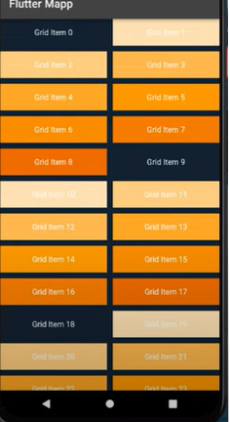
- Data Table - 📊
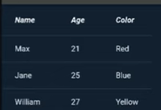
- Data Column - 📊🏛️
- Data Cell - 📊🔲
- Data Row - 📊📈
- DatePicker - 📅
- Date Range Picker - 📅➡️📅
- Decorated Box - 🎨📦
- Decorated Box Transition - 🎨📦⏭️
- Default Text Style - 🅰️⚙️
- Dismissible - ✋🚫
- Divider - ➖
- Draggable Scrollable - 🖱️📜
- Drag Target - 🎯
- Draggable - 🖱️
- Drawer - 🗄️
- Drawer Header - 🗄️🔝
- Dropdown Button - 🔽🔘
- Elevated Button - ⬆️🔘
- Error Details - ❗ℹ️
- Error Widget - ❗🎭
- Expanded - ↔️⬆️
- Expand Icon - ⬇️⬆️
- Expansion Panel List - 📑⬆️⬇️
- Expansion Panel - 📑⬆️⬇️🔲
- Expansion Tile - 📑⬆️⬇️🚪
- Fade In Image - 🖼️↗️
- Fade Transition - 🌫️🎭
- Filter Chip - 🎚️🍪
- Fitted Box - 🔲📦
- Flexible - 🔗
- Floating Action Button - 🚀🔘
- Flow - 🌊
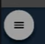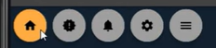
- Flutter Logo - 🐦🆒
- Form - 📋✔️
- Fractional Translation - ⏫🌐
- Fractionally Sized Box - 🔲⚖️
- Future Builder - 🔮🛠️
- Gesture Detector - ✋👆
- Grid Paper - 📏📄
- Grid Tile - 🔲🏞️
- Grid Tile Bar - 🔲📊
- GridView - 🔲🔲🔲
- Hero - 🦸
- Icon - 🔣
- IconButton - 🔘🔣
- Ignore Pointer - 🚫🖱️
- Image - 🖼️
- Indexed Stack - 📚
- Inkwell - 🖋️🌊
- Input Chip - 📥🍪
- Interactive Viewer - 🖐️🔍
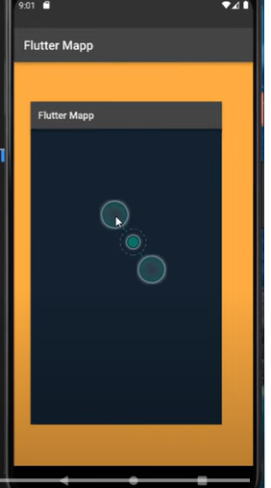
- Layout Builder - 👷🏗️
- Limited Box - 📦⚖️
- Linear Progress Indicator - ➖⌛
- Listener - 👂
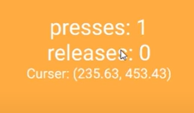
- List Tile - 📋
- ListView - 📜
- List Wheel ScrollView - 🎡📜
- Long Press Draggable - ✋🖱️
- Material App - 📱🎨
- Material Banner - 🎌
- Material Button - 🎨🔘
- Merge Semantics - 🔗🔠
- Modal Barrier - 🚧🔲
- Mouse Region - 🖱️🌍
- NavigationBar - 🧭🔲
- Notification Listener - 🔔👂
- Offstage - 🎭🚫
- Opacity - 🌫️
- Orientation Builder - 🔄🏗️
- Outlined Button - 🔲🔘
- Overflow Bar - 📊🚰
- Overflow Box - 🔲🌊
- Padding - 📏🔲
- Page View - 📑👀
- Physical Model - 🏠🎭
- Physical Shape - 🏠🎨
- Placeholder - ⏳🔲
- Platform Menu Bar - 🖥️🍔
- PopupMenuButton - 🔽🎛️
- **Positioned** - 📍
- 153. Positioned Transition - 📍🔄
- 154. PreferredSize - 🔲📏
- 155. Radio - 📻
- 156. RadioListTile - 📻📋
- 157. RangeSlider - 🎚️🔛
- 158. RawAutoComplete - ✏️✅
- 159. RawChip - 🍪🔍
- 160. RefreshIndicator - 🔄💧
- 161. ReorderableListView - 🔀📜
- 162. RichText - 🅰️🖋️
- 163. RotatedBox - 🔄📦
- 164. RotationTransition - 🔄🎭
- 165. Row - 🚣
- 166. SafeArea - 🛡️
- 167. Scaffold - 🏗️
- 168. ScaleTransition - ⚖️🔄
- 169. Scrollbar - 📜🔍
- 170. SelectableText - 🅰️✋
- 171. Semantics - 🔠🔍
- 172. ShaderMask - 🌞🎭
- 173. Shortcuts - ⌨️🔑
- 174. SimpleDialog - 💬
- 175. SingleChildScrollView - 📜🔍
- 176. SizeTransition - 🔛↔️
- 177. SizedBox - 🔲
- 178. SizedOverflowBox - 🔲🌊
- 179. SlideTransition - ↔️🎭
- 180. Slider - 🎚️
- 181. SliverAppBar - 🍸📜
- 182. SliverFixedExtentList - 📜⬆️
- 183. SliverGrid - 🔲🔲
- 184. SliverList - 📜📜
- 185. SliverOpacity - 📜🌫️
- 186. SliverPadding - 📜📏
- 187. SliverToBoxAdapter - 📜📦
- 188. SnackBar - 🍫📢
- 189. Spacer - 📏🔲
- 190. Stack - 📚
- 191. Stepper - 🚶‍♂️🔢
- 192. StreamBuilder - 🌊🛠️
- 193. Switch - 🔄
- 194. SwitchListTile - 🔄📋
- 195. SystemMouseCursors - 🖱️👆
- 196. TabPageSelector - 📑🔽
- 197. Table - 🏓
- 198. TabBar - 📑🔝
- 199. Text - 🅰️
- 200. Text Button - 🅰️🔘

